**Project 1**

**<Roulette Game>**

**CSC-5**

**Name: Kevin Rivera**

**Date: 11/05/17**

**Introduction**

Title: Roulette

Roulette is a casino game where players choose to place bets on a single number, various grouping of numbers, the colors red or black, whether the number is odd or even, or if the numbers are high (19-36) or low (1-18). To determine a winning number and color, the wheel is spun on a spinning platform with wedges for the roulette ball to land in. The ball is to eventually land on a number of a certain color (black or red) to determine the outcome.

The betting system on this game is simple. If a player bets on a single number—also known as straight bet—the player, then has a chance for a 35/1 payoff. The other bets only add the amount they betted to the dealer. Say if the player bets $35 on odd numbers, but lands on even, you lose the bet. However, if the number were to land on an odd number, they earn $35. Vice versa for even numbers. The game ends when the player decides to step out.

**Summary**

Project size: ~120 lines

Number of variables: 5-10

This program consists of if and else-if statements to determine whether if the player has won the game of roulette. The program runs off a random number generator to find a winning number, or to check if a number is even or odd. The game is a simple concept, yet much can be added to make a more complete game of roulette. In this instance, the program does not have group of numbers, colors, or high or low numbers.

While making the program, I came across multiple programs having to do with reading the inputs and having the program run through the if and else-if statements correctly.

I had to reference to some concepts we did not cover in class such as:

!strcmp – this was to compare the char inputs as I did not use strings using the == operator.

**Description**

The purpose of the program is to provide a game and betting options for the player. This works by checking how much a player wants to bet and what type of bet they would like to place.

**Flowchart**

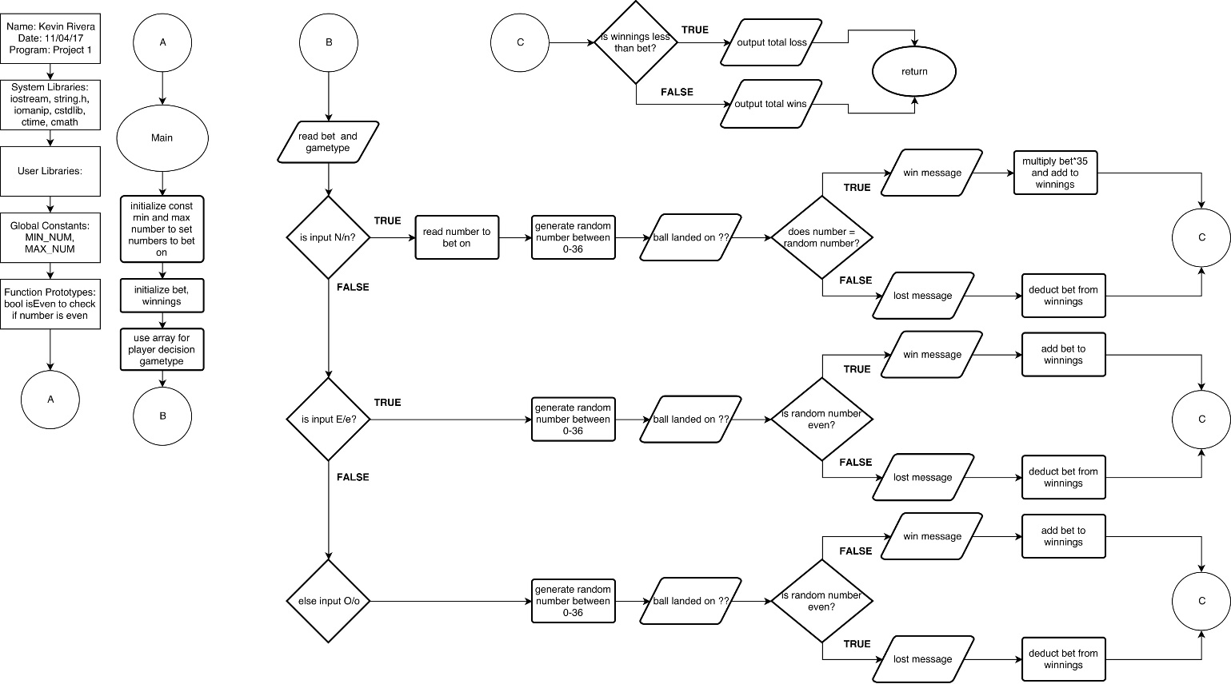

**Pseudocode**

*Initialize*

*Input bet*

*Input bet type*

*If player chooses on specific number*

*If number generated equals number inputted*

*Player wins 35/1 payoff*

*Else*

*Player loses bet*

*If player chooses odd bet*

*If number is odd*

*Player wins bet*

*Else*

*Player loses bet*

*If player chooses even bet*

*If number is odd*

*Player wins bet*

*Else*

*Player loses bet*

*Show results of earnings*

*Program end*

**Major Variables**

|  |  |  |  |
| --- | --- | --- | --- |
| **Type** | **Variable Name** | **Description** | **Location** |
| Integer | MIN_NUM | Lowest number to be generated | main() |
|  | MAX_NUM | Highest number to be generated | main() |
|  | num | Number input for number bet | main() |
|  | rng | Randon number generated | main() |
| Float | bet | Bet inputted | main() |
|  | wins | Total earned/lost | main() |
| Character | gamet | Game type chosen | main() |
| Bool | isEven | Check if number is even | main() |

**C++ Constructs**

|  |  |  |  |
| --- | --- | --- | --- |
| **Chapter** | **Section** | **Topic** | **Line number** |
| 2 | 2 | cout | 30-31 |
|  | 3 | libraries | iostream, iomanip, cmath, cstdlib, fstream, string, ctime |
|  | 4 | variables/literals | 24 |
|  | 5 | Identifiers | 9, 20, 21, 22, 24, 27 |
|  | 6 | Integers | 20-22 |
|  | 7 | Characters | 27 |
|  | 8 | Strings | 38, 63,90 (!strcmp string compare) |
|  | 9 | Floats No Doubles | 24 |
|  | 10 | Bools | 9 |
|  | 12 | Variables 7 characters or less | 9, 20, 21, 22, 24, 27 |
|  | 16 | Named Constants | 21 |
|  | 17 | Programming Style ***** Emulate |  |
| 3 | 1 | cin | 35, 39, 45, |
|  | 2 | Math Expression | 12, 49, 72, 96, 116 |
|  | 8 | Strings | 38, 63,90 (!strcmp string compare) |
|  | 9 | Math Library | 6 |
|  |  |  |  |
| 4 | 1 | Relational Operators | 12, 54, 75, 115 |
|  | 2 | if | 12, 42, 52, 68, 75, 78, 92, 100, 113 |
|  | 4 | If-else | 14 |
|  | 5 | Nesting | 12, 14, |
|  | 8 | Logical operators | 12, 54, 75, 115 |
|  |  |  |  |
| 5 | 1 | Increment/Decrement | 57, 63, 81, 87, 103, 109, |

**Program**

#include <iostream>

#include <string.h>

#include <iomanip>

#include <cstdlib>

#include <ctime>

#include <cmath>

using namespace std;

// bool to check if number is even

bool isEven(int n)

{

if (n%2==0)

return true;

else

return false;

}

int main()

{

// constant for the random numbers to be generated

int const MIN_NUM = 0, MAX_NUM = 36;

int num; // number for input for number gametype

int rng; // random number to be generated

float bet, wins = 0; // bet inputted, total earned/lost

// array for player decisions (number, even, odd)

char gamet[3];

// display main menu

cout << "Welcome to Roulette!\n\n";

// balance //

// player inputs their money for bet

cout << "How much would you like to bet?\n$";

cin >> bet;

// player chooses gametype

cout << "Betting on a specific number (N), odd numbers(O), or even numbers(E)? ";

cin >> gamet;

// run this if player chose inputted N or n

if(!strcmp(gamet,"N")||(!strcmp(gamet,"n")))

{

cout << "What number would you like to bet on? "; // what number to bet on

cin >> num;

// random number generator between 0-36

srand(time(NULL));

rng = rand() % (MAX_NUM - MIN_NUM + 1) + MIN_NUM;

cout << "The ball landed on " << rng << "\n";

// loss

if(num != rng)

{

cout << "You lose $" << bet << "\n";

wins -= bet; // add -bet to winnings

}

// win

else

{

cout << "You win $" << 35*bet << endl;

wins += 35*bet; // multiply bet times 35 and add to winnings

}

}

// inputs E or e for gametype

if((!strcmp(gamet,"E")||(!strcmp(gamet,"e"))))

{

// random number generator between 1-36

srand(time(NULL));

rng = rand() % (MAX_NUM - MIN_NUM + 1) + MIN_NUM;

cout << "The ball landed on " << rng << endl;

if(gamet == "E"||"e")

{

// win

if(isEven(rng))

{

cout << "You win $" << bet << endl;

wins += bet; // add bet to winnings

}

// loss

else

{

cout << "You lose $" << bet << endl;

wins -= bet; // add -bet to winnings

}

}

}

// input O or o for gametype

if((!strcmp(gamet,"O")||(!strcmp(gamet,"o"))))

{

// random number generator between 1-36

srand(time(NULL));

rng = rand() % (MAX_NUM - MIN_NUM + 1) + MIN_NUM;

cout << "The ball landed on " << rng << endl;

// loss

if(isEven(rng)) // check if random number is even

{ // if even, then lose because betted on odd

cout << "You lost $" << bet << endl;

wins -= bet; // add bet to winnings

}

// win

else

{

cout << "You win $" << bet << endl;

wins += bet; // add -bet to winnings

}

}

// final results

if(wins < bet){

cout << "You lost a total of $" << abs(wins); // absolute value used

} // to not show negative

else

cout << "You won a total of $" << wins;

return 0;

}